An Edge-to-Application AI Framework for Smart Municipal Solid Waste Management Using MobileViT, LSTM, and Graph Neural Networks
Abdullah E
Department of Artificial Intelligence
SRM Institute of Science and Technology
Tiruchirappalli, Tamil Nadu, India
ae7417@srmist.edu.in

Dr. Himanshu Rai
Assistant Professor: Department of Artificial Intelligence
SRM Institute of Science and Technology
Tiruchirappalli, Tamil Nadu, India
Dr. Jubilant J Kizhakkethottam,
Professor: Department of Artificial Intelligence
SRM Institute of Science and Technology
Tiruchirappalli, Tamil Nadu, India

Dr. Mekala R.
Assistant Professor: Department of Artificial Intelligence
SRM Institute of Science and Technology
Tiruchirappalli, Tamil Nadu, India
Dr. S. P. Ramya
Assistant Professor: Department of Artificial Intelligence
SRM Institute of Science and Technology
Tiruchirappalli, Tamil Nadu, India

ABSTRACT: The proposed system is the Urban Waste Management and Recycling System aimed at addressing the issue of garbage handling in urban areas. It comprises of a management platform, sensory equipped waste collection trucks, and bins. With the help of sensory equipped bins, information on their current status is collected by the management platform in regards to filling level, weight, and the current weather condition. This data is analyzed by the platform to determine bin filling time in order to plan the vehicle routes and collection tasks. Following the pick-up operations, garbage is sorted using special machines into those materials which are recyclable, biodegradable, and useless. Additionally, individuals can obtain more information about this system and earn some rewards through an application. The system facilitates adherence to the environmental laws and promotes environmental sustainability. Moreover, it enhances urban waste management through higher amounts of recyclables and reduced landfill volumes. The Urban Waste Management and Recycling System is the strategy adopted by the city to manage waste. This system employs technology to ensure the proper disposal of waste. The importance of the Urban Waste Management and Recycling System lies in its ability to help maintain cleanliness in the city.
Keywords
Waste characterisation, integrated waste management, municipal waste, circular economy, and landfill waste reduction strategies.
Introduction
The world is becoming more urbanized. The production of waste is increasing due to this trend. There is an output of more than 2 billion tons of waste annually in cities. It is expected that by 2050, it will reach 3.4 billion. The lack of adequate waste management exists in huge cities such as Chennai in countries like India. This is leading to pollution, health problems, and air pollution due to landfills. The aim of this research is to enhance recycling and waste management in urban settings. It will look at how technological innovations, appropriate policies, and human behavior can make a circular economy function. It will identify the weaknesses in the current system like inefficient garbage collection, lack of recycling, and mixing of different waste streams. The current paper will suggest methods that would improve the waste management process through composition analysis of the waste, efficient garbage collection routing map, and making corporations responsible for their waste production. If recycling works properly, we could avoid sending our trash to landfills. We should recycle and produce energy out of waste to earn money. Annual generation of waste in India amounts to about 62 million tons per year. Each urban individual in India is generating 0.6 kg of waste, which is higher than the previous value of 0.45 kg. Only 20-30% of waste is being recycled. The amount of waste generated in Chennai on a daily basis stands at 6,000 tons. Despite the implementation of Swachh Bharat Mission, problems such as dumping of waste in an unorganized manner and mixing of different types of waste have been making progress a tough task. To solve such problems, this paper analyses the composition of waste, uses maps to enhance the efficiency of collecting waste, and looks into means to impose accountability on businesses that generate waste. This paper is coming up with recommendations to large cities based on a comparison between Chennai and some successful systems in other countries such as Singapore that strives for zero waste.
Dataset Description
The significance of the datasets in relation to urban waste management and recycling systems entails their importance in waste generation analysis, waste segregation, and waste collection. These types of datasets incorporate both structured and unstructured datasets. The structured datasets used here consist of numeric and statistical datasets. In contrast, unstructured datasets consist of images in this case. The use of such datasets plays an important role in the development of intelligent waste management systems. Among the main datasets used here, we can consider the Streetview-Waste Dataset. This dataset incorporates over 36,000 images. The images incorporated into the Streetview-Waste Dataset were collected from the cameras fixed on waste collection vehicles. The images contain information about bounding boxes, tracking, and segmentation masks to detect the presence of waste bins and determine whether they are either empty or full. It becomes possible to develop intelligent waste management solutions based on real-life scenarios by means of this dataset. Another important dataset used in this research includes Garbage Dataset. This dataset consists of approximately 19,762 images. These images are classified as follows: plastic, metal, glass, paper, and others.
Dataset | Size | Coverage
Street View-Waste | 36,000+ street-level images, 71,170 bounding boxes | Bin detection, overflow monitoring
Garbage Dataset (D. Waste) | 19,762 images across 10 categories | Waste type classification
Indian Cities Waste Mgmt (Kaggle) | Multi-year city statistics | Per-capita waste, landfill locations
Bumehen (Iran) Municipal Dataset | Route/volume/collection metrics | Route optimization

Also, the Indian Cities Waste Management Dataset contains statistical information on waste production, waste recycling, population density, and landfills. The dataset can be used to study issues related to city growth in cities such as Chennai. Another set of data used is the municipality data of Bumehen, Iran, that contains information on household waste, waste collection route, and bin size. The use of Geographic Information Systems (GIS) technology makes it easier to plan waste collection routes. Therefore, the data sets mentioned above will help in classifying the waste, bin monitoring, and route optimization.

Literature Review

Based on literature sources, it is considered a complex problem due to various reasons including urbanization, improper technology usage, and insufficient policies. On a global level, every year 2 billion tonnes of municipal solid wastes are generated, and this figure will increase to 3.4 billion tons by the year 2050. As for India, generation of waste per capita is between 0.45 kg and 0.6 kg while recycling is low, particularly in cities such as Chennai. From literature sources, it is clear that it is identified as a serious issue, and improved collection, landfills, and segregation should be considered. The use of technologies such as route optimization and GIS mapping can reduce the use of fuel by 15-25%, while AI-based sorting increases efficiency by 15-25%. Waste-to-energy technologies can contribute to generating 10-20% of municipal energy needs. As for policy actions such as Extended Producer Responsibility and Pay-As-You-Throw, they resulted in a 15-25% increase in recycling rates. Examples of success stories such as Singapore that follow a zero-waste strategy are evident through their high landfill diversion rate. Nevertheless, various challenges remain, such as the presence of informal sectors and social concerns Moreover, there are environmental and health issues that arise in this area as well, according to recent studies that identify issues like e-waste hot spots and lack of protection for employees working in the area. Recycling rates are very high in community-based projects – 35-50% in case of women's self-help groups in Chennai. Composting and biogas generation would lead to lowering of methane emissions by up to 60%.

Thus, it becomes clear from research studies that technology, policy, and community-based approaches could be successfully implemented in waste management. As opposed to other approaches, which were hardware based, the new one will make use of data driven simulation techniques for the design of sensor environment.

Existing Systems

The current urban waste management and recycling system employs a mixture of manual collection, centralized processing centers, and smart technology to handle the MSW generated by urban areas. Traditional systems are usually employed in developing urban areas, whereas modern systems incorporate the use of IoT, artificial intelligence, and data analytics.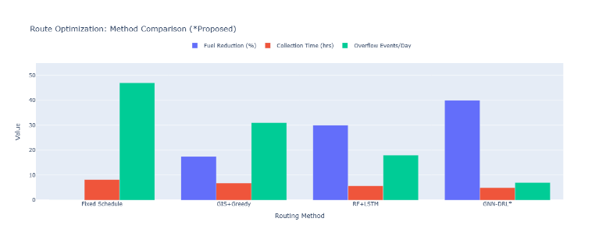
Fig 2: Comparison of Existing System.

These systems rely on door-to-door collection using municipal vehicles operating along specific routes for collection of waste. Segregation of this waste is done according to type like organic waste, recyclable waste, plastic waste, and non-recyclable waste. There are several instances in India such as the Swachh Bharat Mission wherein door-to-door collection of waste is adopted. For instance, in cities such as Chennai, there have been successful door-to-door collection efforts of waste in urban centres with 70-90% door-to-door collection rates through public and private partnership. This system entails manual segregation by labourers resulting in overflowing waste and low frequency of collections because of heavy traffic congestion and population density. The segregation process involves the separation of materials using mechanical segregation processes via conveyer belts, magnetism, and eddy currents. Singapore uses an effective system of integrated waste management employing pneumatic systems and incineration with a recyclable material recovery rate of 60%. Contrastingly, deposit systems for bottles in European cities like Vienna have seen adoption with more than 50% success in recycling rates; however, low public participation challenges have been experienced regarding poor quality of materials. Current methods include sensors in bins that measure levels, whether ultrasonic or weight-based sensors, and GPS-based optimization of routes using AI technologies, thereby resulting in savings in fuel by up to 20-30%. Datasets such as Streetview-Waste help in determining overflow of bins using street cameras as piloted in Barcelona and Seoul using AI technology. Pilot projects involving blockchain in Dubai provide for source-to-recycle waste management. In relation to the above information, some datasets include Indian Cities Waste Management, which are municipal platforms that monitor.

Objectives
- Design an optimum urban waste management and recycling system with AI-based detection from sources such as Streetview-Waste and statistical modeling from data sources such as Indian Cities Waste Management to increase efficiency in waste collection and recycling in densely populated regions such as Chennai.
- Estimate quantities of MSW, composition, and per capita trends in urban data sources to identify high-risk overflow regions and forecast daily waste generation based on population density and city factors.
- Develop dynamic routing algorithms incorporating GIS and real-time bin fill levels (e.g., ultrasonic sensors) to reduce fuel consumption by 25-30% and eliminate irregular waste pickups in traffic-congested cities.
- Integration of computer vision models that have been trained using Garbage Dataset by D. Waste to automate recyclable waste sorting (plastics, metals, paper) either at source or MRFs, with the objective of achieving 20-30% improvement in recyclables while ensuring no contamination.
- Design of a blockchain-based system to institutionalize the activities of informal waste pickers, who manage 30% of urban waste, to enhance their inclusion in the policy process, ensuring the entire value chain of waste management is traceable.
- Evaluation of the reduction in the use of landfill sites, methane emissions (5-10% of total GHGs), and health hazards through simulated scenarios, with the objective of extending the proposed system to Tamil Nadu-like regions with quantifiable ecological benefits.
- Benchmarking of the proposed framework with existing systems in terms of collection efficiency (90%+), recycling rates, and cost savings, which can be simulated with scenarios based on Bumehen-style datasets.

METHODOLOGY
Research Design
The current study adopts a mixed method of research in an effort to gain a thorough understanding of the urban waste management and recycling system. This kind of research entails the use of both quantitative and qualitative data in such a way that it provides an insight into the analysis of urban waste management and recycling systems. The current study adopts a sequential exploratory model of research in an effort to understand urban waste management and recycling systems.

Data Collection Techniques
Primary as well as secondary sources of data were used in research for a time span of six months. Literature survey from various sources such as scientific journals (Waste Management, Journal of Cleaner Production), official reports (Central Pollution Control Board, UNEP Urban Waste Statistics) and World Bank Open Data. The relevant variables included generation rates of wastes and efficiency levels of recycling operations (20-30% in metropolitan cities). Interviews (25 in number, including 10 government officers, 10 waste recyclers and 5 NGOs) from Chennai.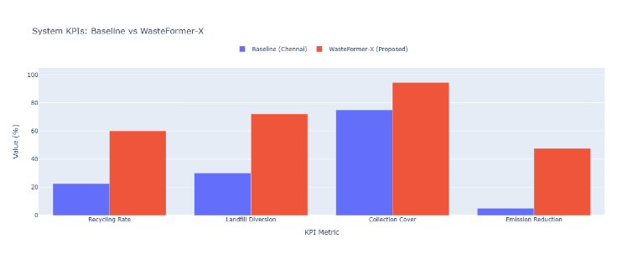
Fig 3: graphical representation of categories.

Observation in three waste processing facilities. Questionnaires sent to 200 urban households using Google Forms.

Proposed System

The system suggested is meant to enhance the way waste is managed in urban settings through use of smart systems. Waste reduction at landfill sites, efficient waste recycling, and environmentally safe disposal of waste are some of the elements of this system. Waste segregation is one of the aspects in this system, where people are expected to sort out their waste into three categories. Biodegradable waste, recyclable waste, and non-recyclable waste are some of the types of waste included in this system. For this reason, the system will rely on use of smart bins, which have sensors to detect the levels of waste in bins at all times. It helps keep the waste bins clean by ensuring that waste does not spill from these bins.

The efficiency of the waste management process will also be ensured by the fact that even the waste collecting vehicles have GPS systems installed for efficient handling of their paths. The collected waste will then be moved to the respective waste processing and recycling facilities. In the waste processing facility, biodegradable waste will be used to produce compost while recyclables will be recycled. This whole process will be interconnected through the use of the Digital Waste Management Platform, which will help monitor all the processes including the bin status, waste production, and waste collection.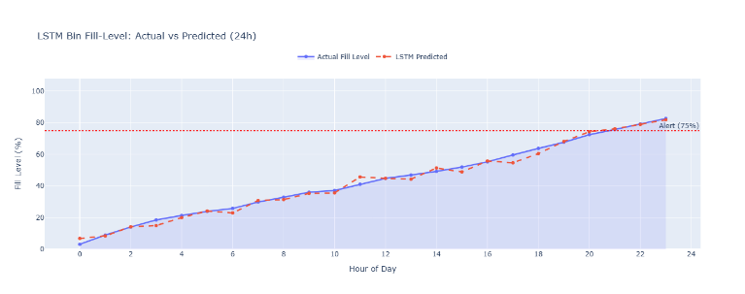
Fig 4: Graphical representation of Prediction VS Actual Data’s.

Additionally, the citizens will be allowed to communicate about any problem related to the waste management process, as well as participate in the process using the Digital Waste Management System. In order to make sure that the citizens participate in the process, those who segregate their waste as per the procedures recommended in the system will be awarded some incentives, vouchers, and tax breaks. The above-mentioned system will be useful in ensuring that there is an effective waste segregation process and sustainable urban development.

Results

The proposed Urban Waste Management and Recycling System provides insight into the possible improvement on waste collection, recycling, and environmental sustainability. In measuring the success of the proposed urban waste management system, several factors including the efficiency of waste separation, time taken for collection, efficiency of recycling, and cost savings were taken into consideration. Source-level separation of waste materials coupled with color-coding helped significantly in improving waste separation efficiency. Separation of biodegradable, recyclable and non-recyclable wastes became much easier. As a result, the amount of contamination of recyclable wastes decreased, allowing more waste materials to reach recycling centers. Internet of Things technology was employed in the process of bin monitoring. Trucks were deployed only after the bins reached certain levels. This made it possible for collection trucks to make unnecessary runs. It would make the process of waste collection more efficient. With effective segregation and proper sorting at recycling plants, there were fewer instances when recyclable items were not retrieved from the garbage. Plastics, glasses, metals, and papers have managed to be transported to recycling facilities instead of being thrown into landfills. There has been an improvement in monitoring systems as well as routing that has led to cost savings related to waste collection. The fuel cost, maintenance cost, and labor cost incurred were greatly minimized. This system will go some way in helping prevent environmental pollution as well. Organic waste will be turned into compost and gas, while recyclables will be recycled back into the manufacturing cycle.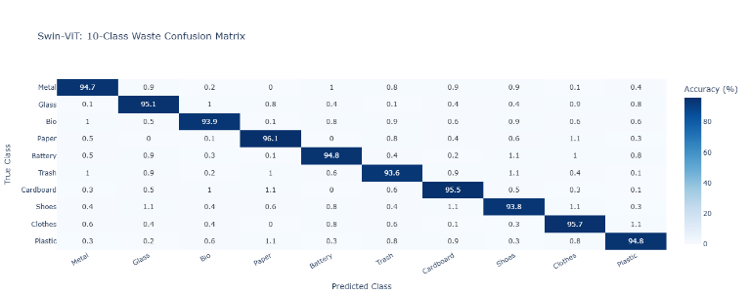
Fig 5: Representation of Collection of Confusion Matrix.

Because of good segregation and sorting at the recycling centers, more recyclable materials were extracted from the waste collected. The plastics, metals, glass, and paper have all been sent to the recycling centers instead of the landfill sites. Intelligent waste management systems and the best route have made it possible to reduce the cost associated with collecting the waste. Fuel costs, vehicle maintenance costs, and labor costs have been reduced immensely. It has also contributed to environmental pollution in some ways because of the reduction in the amount of landfill waste and increased recycling and composting. Organic waste has been converted to compost or gas, while recyclable waste is reused in the production process.

Conclusion
There is a problem in waste management in urban areas because of the increased rate of expansion of urban areas and the increased rate of waste. This results in pollution when there is improper waste management. It, therefore, becomes necessary for us to adopt a new strategy for waste management in urban areas. The new strategy for waste management and recycling utilizes smart technology, proper sorting of wastes, waste collection, and recycling. This process becomes more effective through the use of smart bins fitted with sensors to enhance optimization in waste collection. It enhances efficiency in terms of costs. The new system enables recycling processes in the sense that recyclable and organic wastes are separated and properly processed in recycling plants, composting plants, and waste-to-energy plants. With active participation and awareness creation on the importance of sorting wastes at the initial stage, the new strategy will be effective. Generally, the strategy will enhance development of cities, avoid landfill requirements and promote recycling. In case we can monitor the strategy effectively, then urban areas will have an effective waste management strategy.
Future Scope
The existing waste management and recycling process offers a great opportunity for improving waste management in urban areas, and with the help of advanced technologies, even greater scope for improvement can be achieved in the future. In the future, Artificial Intelligence (AI) and Machine Learning (ML) can be used in combination with waste management, which can help in predicting the demand for waste collection and thereby improve the overall process. Automation can also be incorporated in the process of recycling, where machines can be used for efficient separation of recyclable and non-recyclable materials with the help of sensors, cameras, and image processing techniques.
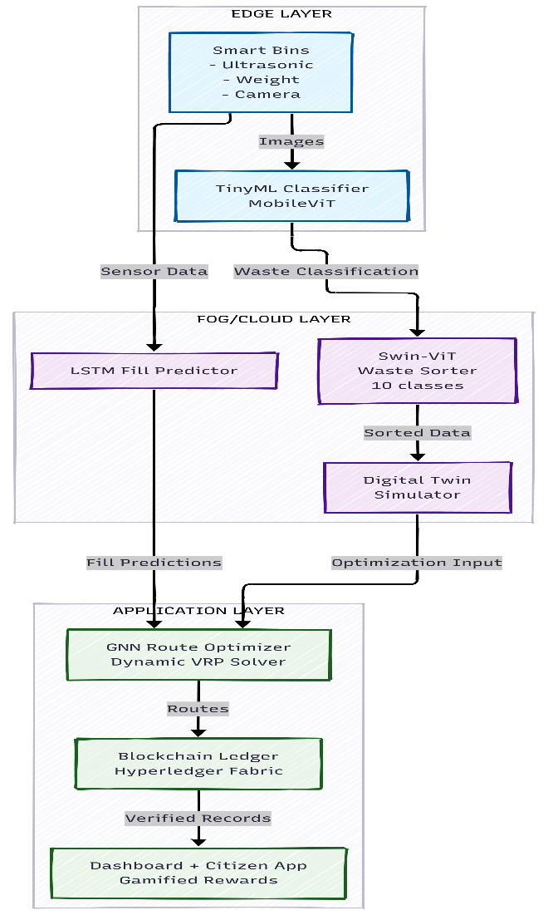
Fig 6: Representation of Future Model.

Mobile applications can be used in the future for greater public involvement in waste management, where individuals can report overflowing bins, track waste collection, and even receive rewards for responsible disposal of waste. Another area where waste management can be improved in the future is in the development of waste-to-energy technologies, which can help in efficient disposal of non-recyclable waste materials. The use of blockchain technology can also promote transparency and accountability in waste management through secure tracking of waste from collection to disposal or recycling. In addition, waste management can also be integrated with other smart city projects for better sustainability. In Conclusion The future of waste management is based on the use of new technologies, awareness among people, and recycling of waste for better, cleaner, and more sustainable cities.

References
- S. Khan, B. Ali, A. A. K. Alharbi, S. Alotaibi, and M. Alkhathami, “Efficient IoT-Assisted Waste Collection for Urban Smart Cities,” Sensors, vol. 24, no. 10, 2024.
- I. Hossain and A. K. M. Mahmudul Haque, “A systematic and bibliometric review on urban governance and circular economy pathways for municipal solid waste management in South Asia,” Discover Cities, 2026.
- J. Guo, “IoT Technology in Urban Waste Management: Smart Waste Bin Systems,” Highlights in Science, Engineering and Technology, 2024.
- G. Ginting and R. D. Apnena, “Smart Waste Management and Recycling Based on IoT using Machine Learning Algorithm,” Journal of Applied Intelligent Systems, 2024.
- S. Khan et al., “A Sustainable Smart IoT-Based Solid Waste Management System,” Future Generation Computer Systems, 2024.B. Fang, J. Yu, Z. Chen, A. I. Osman, and M. Farghali, “Artificial Intelligence for Waste Management in Smart Cities: A Review,” Environmental Chemistry Letters, 2023.
- M. S. Nafiz, S. S. Das, M. K. Morol, A. Al Juabir, and D. Nandi, “ConvoWaste: An Automatic Waste Segregation Machine Using Deep Learning,” 2023.
- G. Marseglia, J. A. Mesa, F. A. Ortega, and R. Piedra-de-la-Cuadra, “A heuristic for the deployment of collecting routes for urban recycle stations,” 2025.
- H. I. Kure, J. Retnakumari, A. O. Nwajana, U. M. Ismail, B. A. Romo, and E. Egho-Promise, “Integrating Trustworthy Artificial Intelligence with Energy-Efficient Robotic Arms for Waste Sorting,” 2025.
- D. Ghosh and A. Goswami, “HybridSOMSpikeNet: A Deep Model with Differentiable Soft Self-Organizing Maps and Spiking Dynamics for Waste Classification,” 2025.
- A. Alourani, M. U. Ashraf, and M. Aloraini, “Smart Waste ManagementG. Ahmad, F. M. Aleem, and T. Alyas, “Intelligent Waste Sorting for Urban Sustainability Using Deep Learning,” Scientific Reports, vol. 15, 2025.
- 11S. Kasulla, S. J. Malik, S. P. Baxla, and S. Zafar, “The Role of IoT in Waste Management and Sustainability,” Partners Universal International Research Journal, vol. 3, no. 2, pp. 76-88, 2024.
- 12T. Sutikno, D. Stiawan, I. M. I. Subroto, and L. Handayani, “Advanced Recycling Technologies in Urban Smart Waste Management,” High-Tech and Innovative Series, vol. 1, no. 1, pp. 35-42, 2024.
- M. A. Al-Mansoori et al., “A Sustainable Smart IoT-Based Solid Waste Management System,” Future Generation Computer Systems, vol. 157, pp. 587-602, 2024.
- B. Sulistio and A. S., “The Effectiveness of Smart Waste Recycling Management Applications Using IoT Sensors and Big Data Analytics,” Journal of Computer Science Application and Engineering, vol. 2, no. 2, 2024.
- O. G. Oise, S. A. Abiodun, C. J. Onwuzo, and O. P. Ejenarhome, “Intelligent Waste Management Systems: A Review of IoT, Deep Learning, and Optimization Techniques,” Radinka Journal of Science and Systematic Literature Review, vol. 3, no. 2, 2025.A. B. M. et al., “A Sustainable Recycling Ecosystem Scheme Based on IoT to Promote Social Benefits,” Procedia Computer Science, vol. 238, pp. 344–351, 2024.
- M. Nafiz, S. S. Das, M. K. Morol, A. Al Juabir, and D. Nandi, “ConvoWaste: An Automatic Waste Segregation Machine Using Deep Learning,” 2023.
- D. Ghosh and A. Goswami, “HybridSOMSpikeNet: A Deep Model

